**Static method Example**

Create class Test with following members:

* public static integer variable var1= 20.
* public integer variable var2=70.
* instance method to print value of var1 and var2.
* static method to change value of var1 and var2 then calles instance method to print value of var1 and var2.

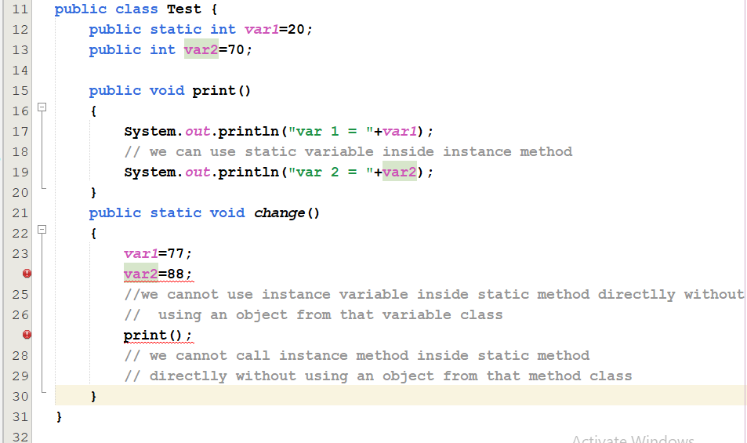

**To correct the errors we should do the following:**

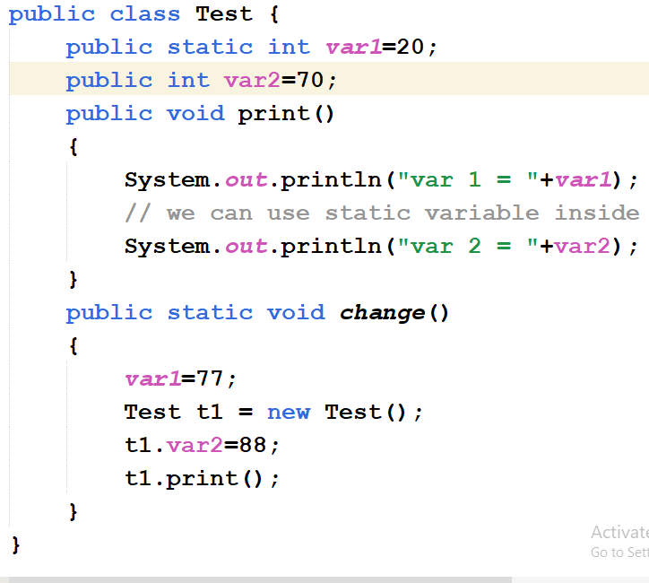

Notes:

* Methods can also be static.
* Static methods can be called using class names in another class.

**Ex: Test.change()**

* In order to use instance variables inside a static method, an object from the class of the instance variable is needed.
* It is possible to use static variables inside non-static methods directly.
* The main method which is the entry point of the application is declared as a static method.
* The main method is static because it can be invoked without an object.